1. What is your computers IP address? (This is not included in your traceroute results). Take a screenshot of your computers IP address

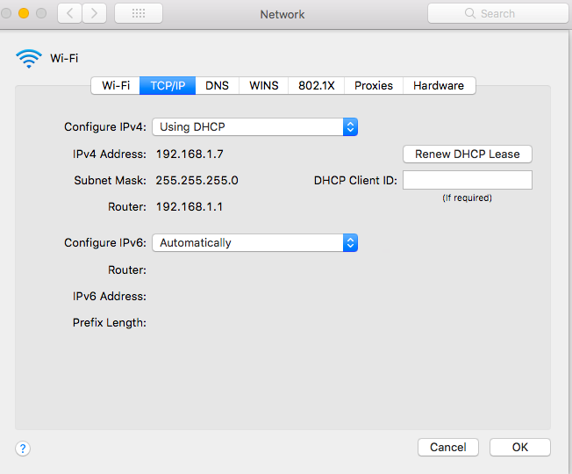

My Computers IP Address is 192.168.1.7

1. With reference to private/public IP addresses. What type of IP address is the first IP from your traceroute result.

The first IP Address is a private address 192.168.1.1

1. With reference to private/public IP addresses. What type of IP address is the second IP from your traceroute result.

The Second IP Address is a public address 71.191.184.1

1. In a tabular format (use table example below), and in sequential order. Indicate the location of each IP address (include state for US states) and the organization that owns the IP address. (Use https://www.ultratools.com/tools/ipWhoisLookup to look up IP address who is information).

|  |  |  |  |
| --- | --- | --- | --- |
| Hop Count | IP address | Organization (IP Owner) | Location, (US state)/Country |
| 1 | 192.168.1.1 | Internet Assigned Numbers Authority(IANA) | Los Angeles,CA |
| 2 | 71.191.184.1 | MCI Communications Services, Inc. d/b/a Verizon Business | Ashburn, VA |
| 3 | 100.41.218.8 | MCI Communications Services, Inc. d/b/a Verizon Business | Ashburn, VA |
| 4 | *** |  |  |
| 5 | 140.222.229.165  140.222.239.77  140.222.229.165 | ANS CO+RE Systems, Inc. | Purchase, NY |
| 6 | 204.148.11.177 | ANS Communications, Inc | Ashburn, VA |
| 7 | 213.254.230.254 | whois.ripe.net | -- |
| 8 | 46.33.80.34 | whois.ripe.net | -- |
| 9 | 203.208.172.173 | Singapore Telecommunications Pte Ltd | Singapore |
| 10 | 203.208.177.130 | Singapore Telecommunications | Singapore |
| 11 | 59.154.142.16  59.154.142.22  59.154.142.20 | SingTel Optus Pty Ltd | AUSTRALIA |
| 12 | 161.43.103.42 | SingTel Optus Pty Ltd | AUSTRALIA |
| 13 | 210.56.92.11 | NBN, Private IP, IPWAN, MPLS & ADSL broadband technologies | AUSTRALIA |
| 14 | 122.129.216.9 | Web Prophets Pty Ltd | AUSTRALIA |

1. In your own words, explain everything you just did, and what route did your packet took from source to destination. How many US states did your packet go through? How many countries if any?

The route started from a private address that connected to the public IP address in Ashburn, VA. Then went to Purchase, NY and came back to Ashburn, VA, then goes to a couple of organization in Singapore and ends in Australia after going through multiple organizations.